Template for national conference (MECHMASTIC-2k17)
Paper Title (16pt Times New Roman, Bold, Center Aligned)
Correspondence Author^{*1} , Co-Authors ⁴(12pt Times New Roman, Bold, Center Aligned)
^{*1,2}Designation, Department College, Country (12pt Times New Roman, Center)

ABSTRACT (14 pt Times New Roman, Bold, Capital Letters)

An abstract of no more than 200 words (12pt Times New Roman, Justified).

Keywords: 2-6 Keywords are required (10pt Times New Roman, Italic, and Justified).

- INTRODUCTION(14 Pts Times New Roman, Bold, Capital Letters, Left Aligned)

All content should be written in English and should be in single column.
- A4 Page type with normal margin, line spacing should be 1.5.
- No space should be added before or after paragraph.
- All sections should be typed in character size 12pt Times New Roman, Justified.
- METHOD & MATERIAL(14 Pts Times New Roman, Bold, Capital Letters, Left Aligned)

Subheading should be 12pt Times new Roman, justified.
This section should be typed in character size 12pt Times New Roman, Justified.
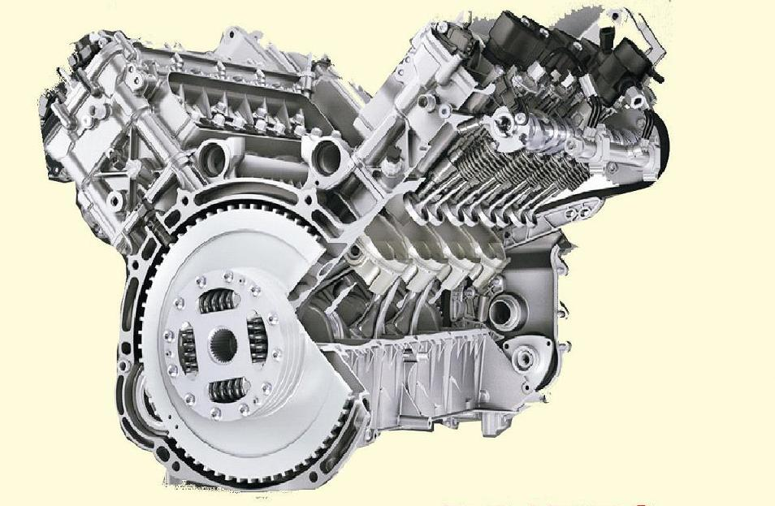

Figure: 10pt Times New Roman, Bold, centered.

Sub-subheading
Sub-subheading should be 12pt Times new roman, Italic, Justified.

- OTHER SECTIONS (14 Pts Times New Roman, Bold, Capital Letters, Left Aligned)

This section should be typed in character size 12pt Times New Roman, Justified.

- RESULT & DISCUSSION(14 Pts Times New Roman, Bold, Capital Letters, Left Aligned)

The results and discussion may be combined into a common section or obtainable separately. They may also be broken into subsets with short, revealing captions.
This section should be typed in character size 12pt Times New Roman, Justified

- CONCLUSION (14 Pts Times New Roman, Bold, Capital Letters, Left Aligned)

This fragment should obviously state the foremost conclusions of the exploration and give a coherent explanation of their significance and consequence.
This section should be typed in character size 12pt Times New Roman, Justified.

- ACKNOWLEDGEMENTS (14 Pts Times New Roman, Bold, Capital Letters, Left Aligned)

This section should be typed in character size 12pt Times New Roman, Justified.

REFERENCES (14 Pts Times New Roman, Capital Letters, Left Aligned).

All the references should be contained or mentioned in the manuscript in ascending order

[1] S. S. Wang “Fracture mechanicsfor delamination problems incomposite materials,” Journal of Composite Materials, (1983), vol.17(3), pp. 210-223.
[2] M. Niino, T. Hirai and R.Watanabe, “The functionallygradient materials,” J Jap SocCompos Mat, vol.13, pp. 257-264.
[3] Report on “Fundamental study onrelaxation of thermal stress forhigh temperature material by tailoring the graded structure”,Department of Science and Technology Agency, (1992).

Template for south India project exhibition (SIPE-2k17)
Project title (16 pt, Times New Roman, Capital Letter, Left Aligned)
Correspondence Author^{*1} , Co-Authors ⁴(12pt Times New Roman, Bold, Center Aligned)
^{*1,2}Designation, Department College, Country (12pt Times New Roman, Center)

- ABSTRACT (14 PT TIMES NEW ROMAN, BOLD, CAPITAL LETTERS, CENTER ALIGNED)

All content should be written in English and should be in single column.
- A4 Page type with normal margin, line spacing should be 1.5.
- No space should added before or after paragraph.
- All sections should be typed in character size 12pt Times New Roman, Justified.
- PROJECT FIGURE/ LINE DIAGRAM

- CONCLUSION (14 PT TIMES NEW ROMAN, BOLD, CAPITAL LETTERS, LEFT ALIGNED)

This fragment should obviously state the foremost conclusions of the exploration and give a coherent explanation of their significance and consequence.
This section should be typed in character size 12pt Times New Roman, Justified.

