SPORTS REPORT 2019-2020

ODD SEMESTER
VTU INTERCOLLIGATE GAMES PARTICIPATION AND HOSTED BY KIT
SLNO | GAME | VENUE | DATE | REMARKS
01 | Badminton (M&W)  Central Karnataka Zone | SJMIT, Chitradurga. | 26th and 27th August 2019. | Both Men & Women Reached Semi-Finals.
02 | Yoga (M&W)  Single Zone | HIT, Nidasoshi, Chikkodi. | 13th to 14th September 2019 | Vishnuprasad Shetty 7th sem MECH secured 1st place & Pooja K 5th sem ECE secured 2nd place. Our Both Team gave a good performance.
03 | Basket Ball (M) CK Zone | KIT,Tiptur. | 14th and 15th September 2019. | Good Performance
04 | TAEKWONDO (M) Single Zone | GAT, Bengaluru. | 17th & 18th October 2019. | Good Performance
05 | Athletics (M & W) Single Zone | GNDEC, Bidar. | 22nd to 25th October 2019 | Good Performance
06 | Throwball (W)  Central Karnataka Zone  & Inter Zone | CK Zone PESITM, Shivamoga, I Zone Jyothi IT, Bengaluru. | 18th and 19th November 2019 | Runners at CK Zone & Inter Zone Quarter Finals.
07 | Table Tennis(M & W) Central Karnataka Zone | SIT, Tumkur. | 21st & 22nd November 2019 | Both Men & Women Reached Semi-Finals.

EVEN SEMESTER
VTU INTERCOLLIGATE GAMES PARTICIPATION AND HOSTED BY KIT
SLNO | GAME | VENUE | DATE | REMARKS
01 | CROSS COUNTRY (M) | DR.TTIT, KGF | 24th and 25th FEB 2020 | Our team gave Good performance.
02 | KHO-KHO (M) | SIT, TUMKUR | 27th and 28th FEB 2020 | Our team gave good performance & REACHED SEMIFINALS.
03 | VOLLEYBALL (M) | HMSIT, TUMKUR | 05th to 06th March 2020 | Our team gave Good performance.
04 | CRICKET (M) | SIT, TUMKUR | 07th March 2020 | Our team gave Good performance.
05 | VOLLEYBALL (W) | KIT , TIPTUR | 13th to 14th March 2020 | Our team gave good performance & secured 4th Place.

VARIOUS SPORTS EVENTS INAGURATION PHOTOS ORGANIZED BY THE DEPARTMENT OF PHYSICAL EDUCATION, KIT 2019-20.
- VTU Inter Collegiate Bangalore Zone Volleyball Tournament (Women) on 13th & 14th of March 2019-20, in this Tournament the Chief Guest was Ms. SWETHA .N, Former International Volleyball Player.
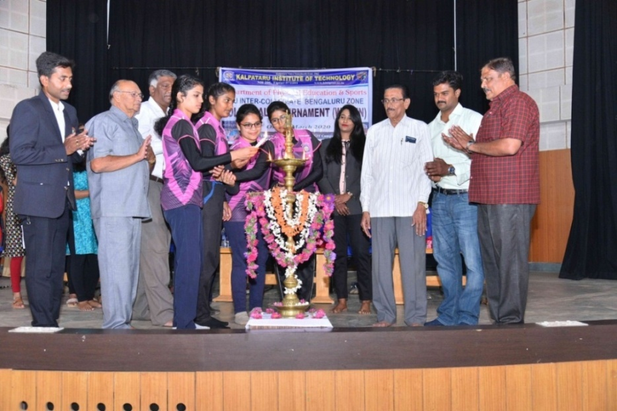

- VTU Inter Collegiate Central Karnataka Zone Basketball Tournament (MEN) on 24th & 25th of September 2019-20. In this Tournament the Chief Guest was Mr. SANJAY RAJ, Former International Basketball Player & Indian Team Captain
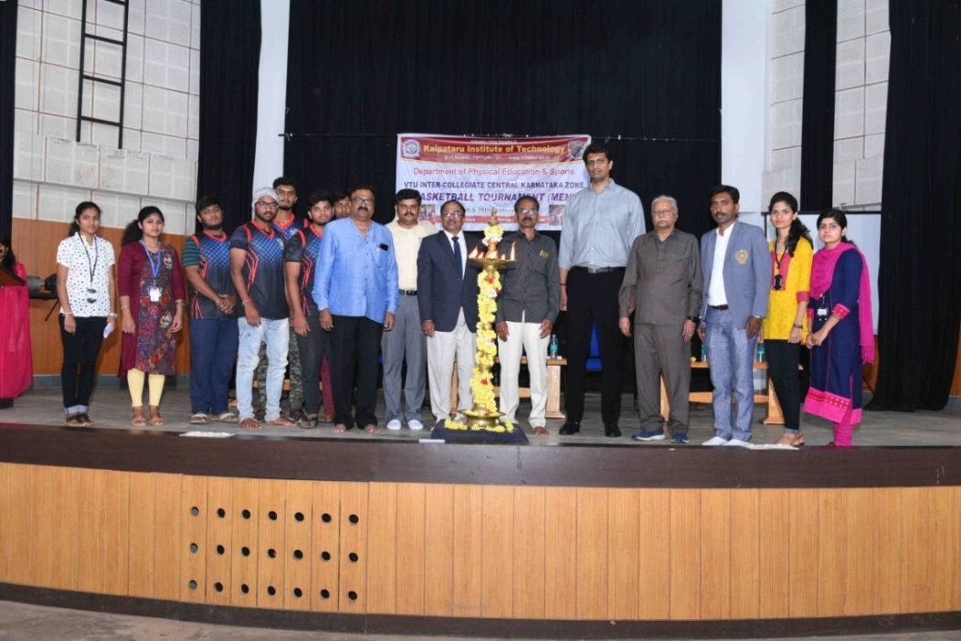
VARIOUS SPORTS ACHIVEMENT PHOTOS OF KIT SPORTS TEAM 2019-20

- Institutional Cash Award of Rs.1 Lakh to our college as per their participation and achievements in the Sports activities at VTU on the occasion of “Achiever’s Day” on 19th October 2019-20.
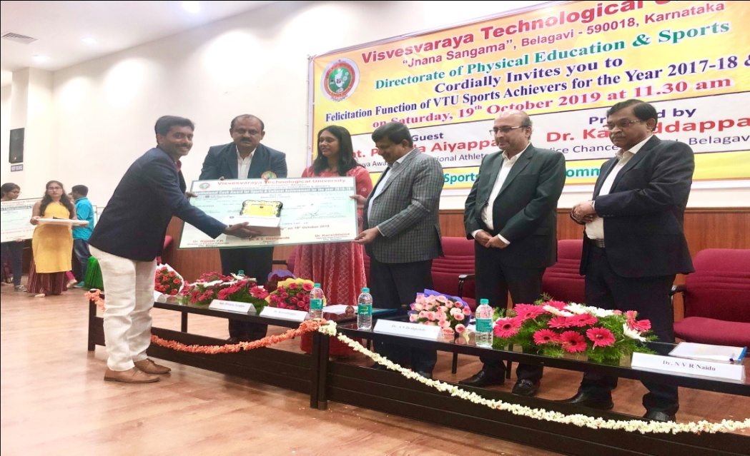

- Our College selected to organize MEGA EVENT VTU Athletic Meet 2019-20.
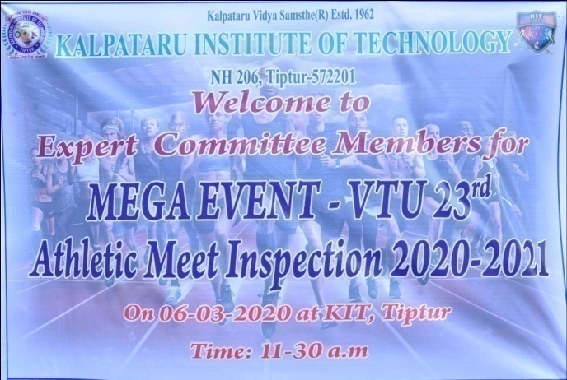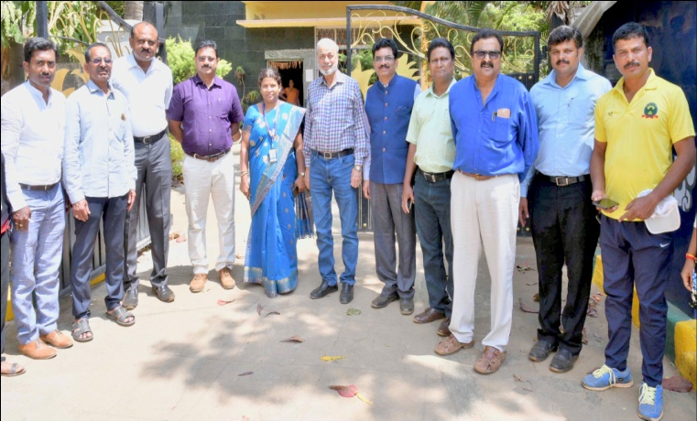
But due to the COVID-19 situations VTU had postpone to next year.

- VTU Inter Collegiate Bangalore Zone Volleyball Tournament Women 4th Place at KIT on 13th & 14th of March 2019-20.

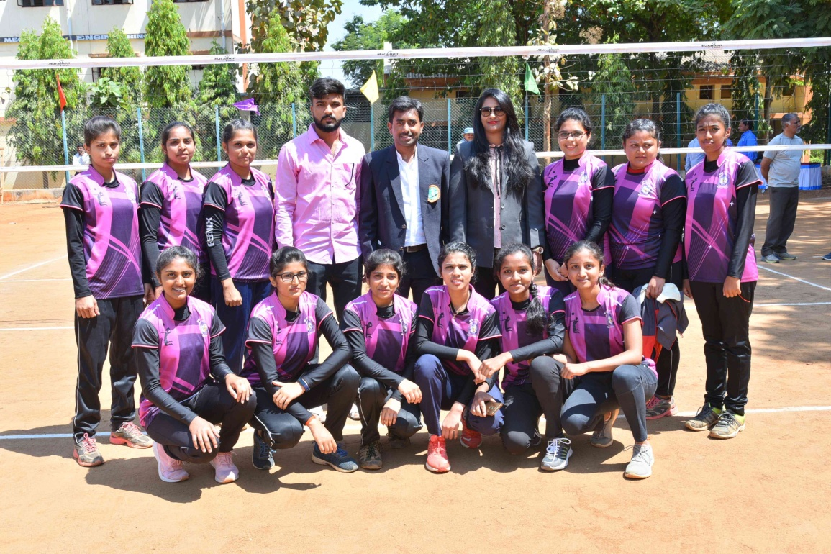

- VTU Inter Collegiate Central Karnataka Zone Throwball Tournament Women Runners- up at PESIT, Shivmogga on 18th and 19th NOVEMBER 2019-20.
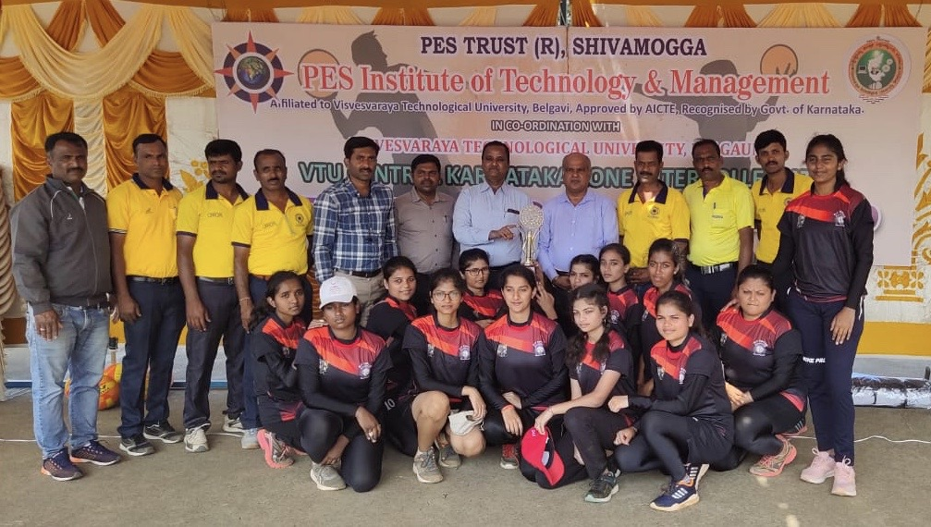

- VTU Intercollegiate Single Zone M&W Yoga Championship secured Gold & Silver Medal held at HIT, NIDASOSHI, CHIKKODI on 13th to 14th SEPTEMBER 2019-20.
